Sik telemetry radio

노트북 연동 방법

작성일: 2019년 4월 28일

작성자: 성병문

# Sik Telemetry Radio 구성

A *SiK Telemetry Radio* is one of the easiest ways to setup a telemetry connection between your Flight Controller and a ground station.

[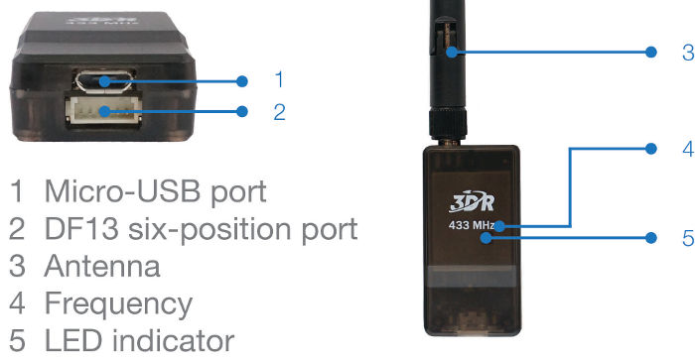](http://ardupilot.org/copter/_images/3dr_radio_v2.jpg)

# Pixhawk 연결

Use the 6 pin DF13 connector that should have come with the radio to connect the radio to your Pixhawk’s “Telem 1” (“Telem 2” or “Serial 4/5” can also be used but the default recommendation is “Telem1”).

[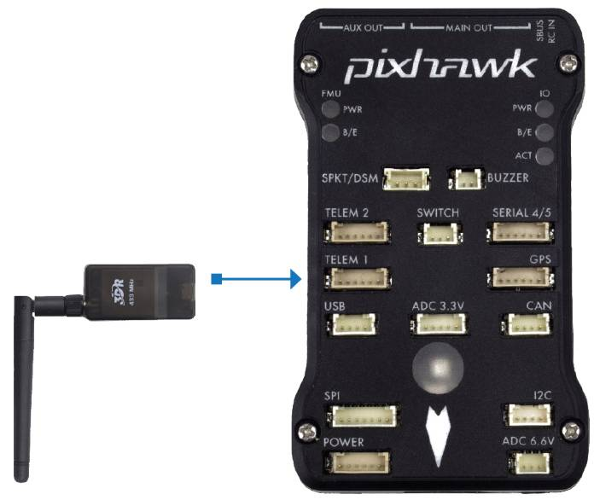](http://ardupilot.org/copter/_images/Telemetry_3DR_Radio_Pixhawk.jpg)

# PC 연결

Connecting the radio to your Windows PC is as simple as connecting the micro USB cable (which should have been included with the radio) to your PC. The necessary drivers should be installed automatically and the radio will appear as a new “USB Serial Port” in the Windows Device Manager under Ports (COM & LPT). The Mission Planner’s COM Port selection drop-down should also contain the same new COM port.

[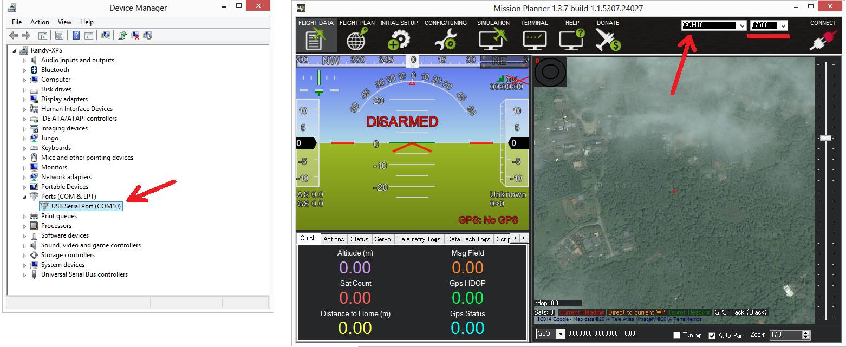](http://ardupilot.org/copter/_images/Telemetry_3drRadio_DeviceManagerAndMP.jpg)

To connect the radios:

* Select the new COM port, set the baud rate drop down (which appears between the COM port and Connect buttons) to 57600.
* Press the **Connect** button and if the two radios connect successfully you should be able to lean your vehicle left and right and see it’s attitude update on the MP’s Flight Data screen’s artificial horizon.

# Connecting to an Android tablet

Connecting the radio to an Android tablet using the L shaped micro USB cable (which should have been included with the radio). Then follow the directions in your [preferred Ground Station app](http://ardupilot.org/copter/docs/common-choosing-a-ground-station.html#common-choosing-a-ground-station).

[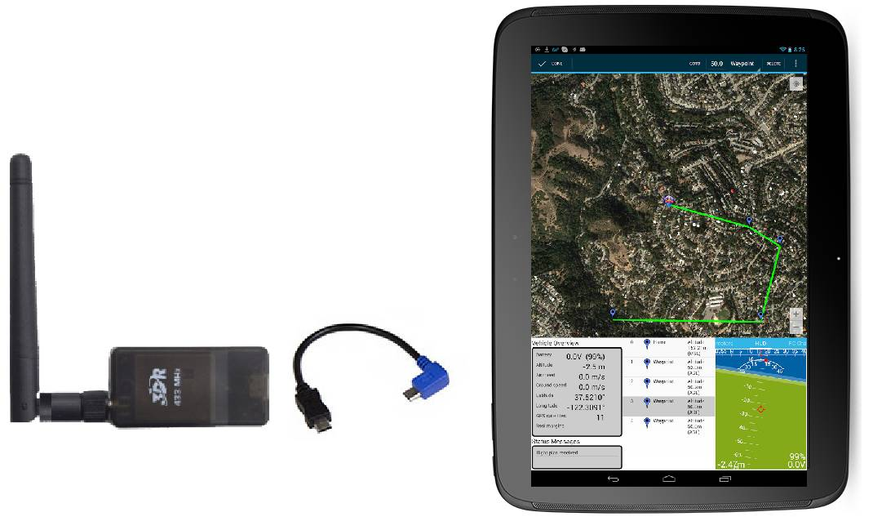](http://ardupilot.org/copter/_images/Telemetry_3DR_Radio_Tablet.jpg)

# Configuring using the Mission Planner

Many users will not need to configure their radios! One case where you might do so is when you use your vehicle with others — in which case you will need to specify different radio channels (Net ID).

# RFD900 Radio Modem

The RFD900 Radio Modem is a high powered 900Mhz, ISM band radio modem designed for long range serial communication. Ranges of [15km and much higher have been reported](http://www.edgeresearchlab.org/our-projects/edge4-16-feb-2013/rfd900/).

**Warning**

These modems are high-power RF devices. It is suggested to provide separate +5 voltage to the modems. It is NOT suggested to power these modems directly from Autopilots telemetry port

[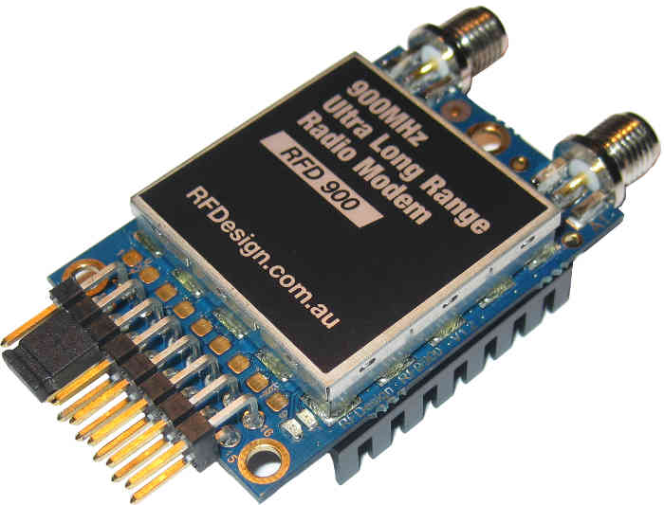](http://ardupilot.org/copter/_images/RFD900_telemetry_radio.jpg)

Users can either use radio modem unit itself and acquire antennas, cables as separate or by getting ready made telemetry sets as in below:

[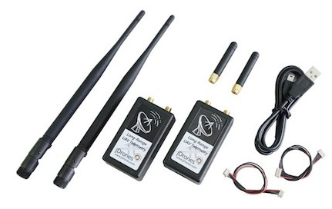](http://ardupilot.org/copter/_images/jDrones_RF900PlusSET_NoLogo.jpg)

- 끝 -